

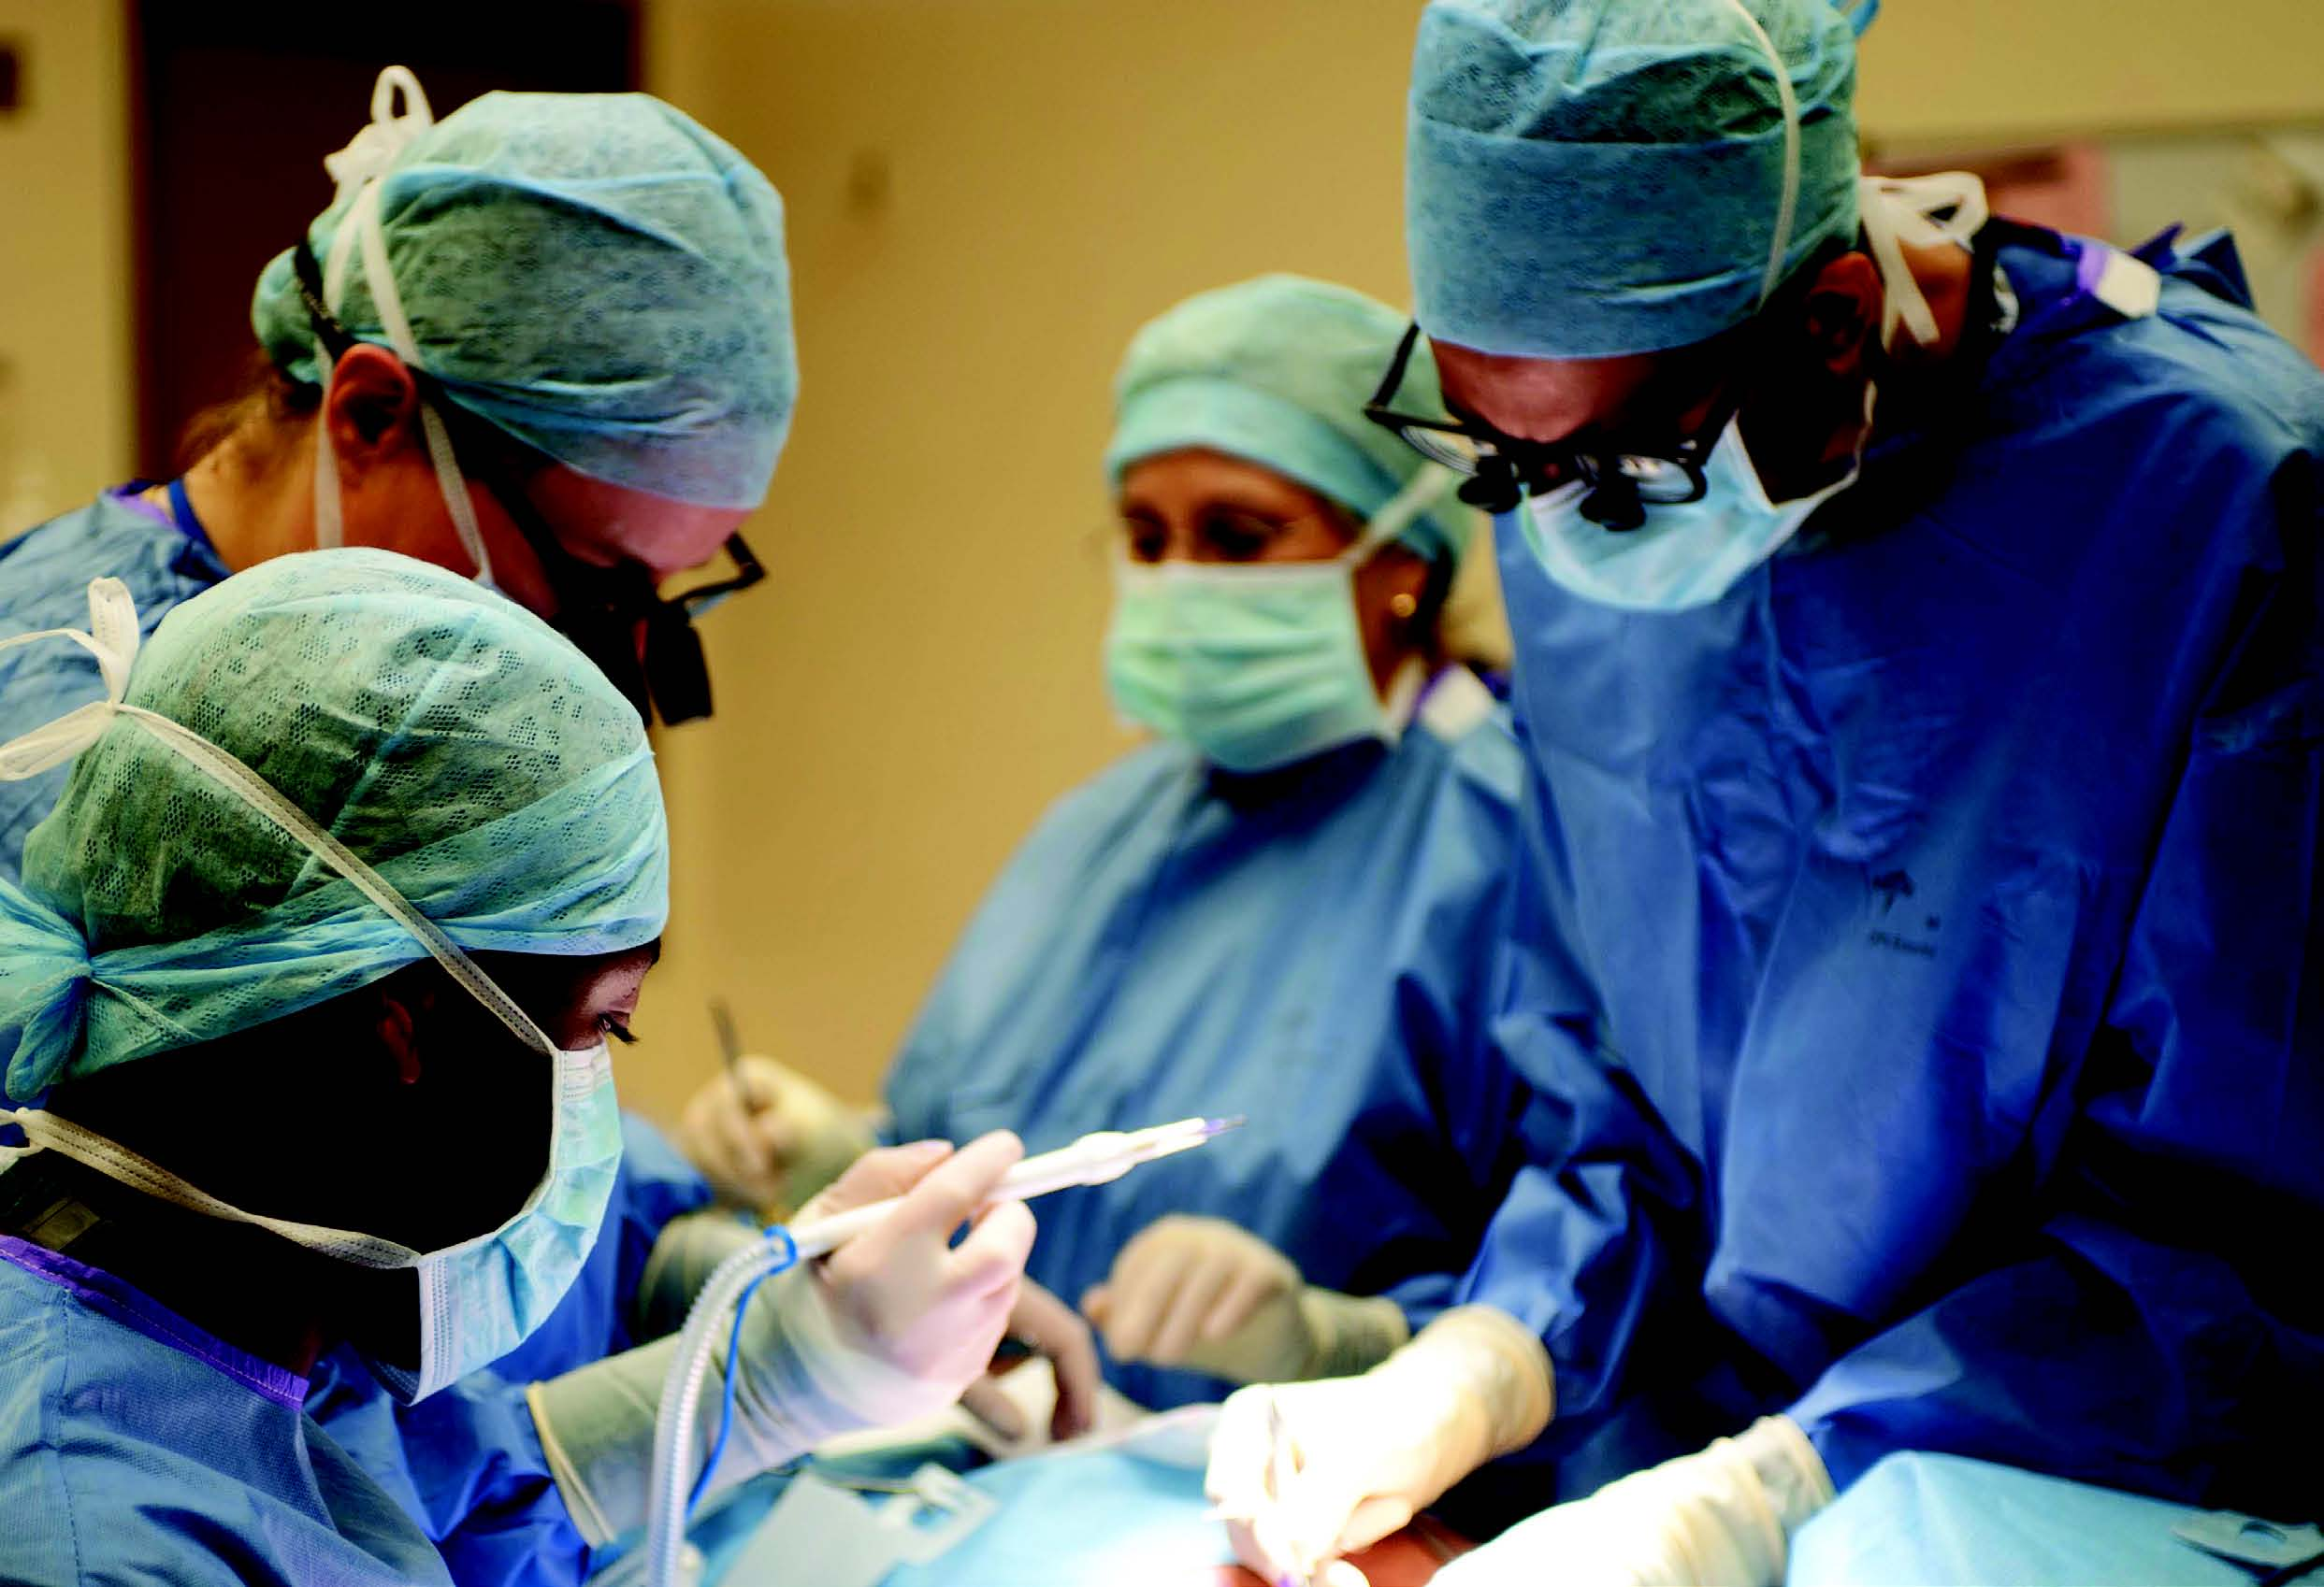

Surgical Specialty Lead Application Form

# Surgical Specialty Lead

RCSEng, ACPGBI and Bowel Research UK are inviting application for the role of Surgical Specialty Lead for Colorectal Surgery

Requirements

• Deadline for applications is **midday Friday 19 September 2025.**

• Shortlisted candidates will be interviews face-to-face from **10:30 on Friday 26 September 2025**. Please save this date as an alternative date for interviews cannot be provided. If you are unable to attend the interview in person please make this clear when submitting your application.

Contact

• Please submit completed application forms or any questions regarding the application process to Murat Akkulak, RCS England Clinical Research Manager, on [makkulak@rcseng.ac.uk](mailto:makkulak@rcseng.ac.uk)

|  |
| --- |
| Section 1 |

|  |  |  |  |
| --- | --- | --- | --- |
| **1.1 - Contact Details** | | | |
| **Individual** | | | |
| Title |  | Initials |  |
| First Name |  | | |
| Last Name |  | | |

|  |  |  |
| --- | --- | --- |
| **Unit** | | |
| Department |  | |
| Faculty / School |  | |
| Host Institution |  | |
| Address |  | |
|  |  | |
|  |  | |
| Postcode |  | |
|  | | |
| Email | |  |
| Telephone | |  |
| Fax (if available) | |  |

|  |
| --- |
| Section 2 - Experience of Surgical trials |

**2.1 Please describe your experience to date, of working on multicentre clinical trials (500 words)**

|  |
| --- |
|  |

**2.2 Please provide 3 examples of multicentre trials to which you have contributed.**

|  |  |  |  |  |  |
| --- | --- | --- | --- | --- | --- |
| Name of trial |  | | | | |
| NIHR Portfolio status |  | Trial Design |  | | |
| Surgical Discipline |  | | | | |
| Chief Investigator |  | | | Speciality |  |
| Your Role (e.g. PI/CI) |  | | | | |
| Your contribution  (< 50 words) |  | | | | |

|  |  |  |  |  |  |
| --- | --- | --- | --- | --- | --- |
| Name of trial |  | | | | |
| NIHR Portfolio status |  | Trial Design |  | | |
| Surgical Discipline |  | | | | |
| Chief Investigator |  | | | Speciality |  |
| Your Role (e.g. PI/CI) |  | | | | |
| Your contribution  (< 50 words) |  | | | | |

|  |  |  |  |  |  |
| --- | --- | --- | --- | --- | --- |
| Name of trial |  | | | | |
| NIHR Portfolio status |  | Trial Design |  | | |
| Surgical Discipline |  | | | | |
| Chief Investigator |  | | | Speciality |  |
| Your Role (e.g. PI/CI) |  | | | | |
| Your contribution  (< 50 words) |  | | | | |

**2.3 Please outline a plan for how you will develop new researchers (including trainees) and new studies over the next 3 years (500 words)**

|  |
| --- |
|  |

|  |
| --- |
| Section 3 - Research Proposal Outlines |

Please give one example of a surgical trial that you plan to work up

**3.1.1 - Research project title**

|  |
| --- |
|  |

|  |  |
| --- | --- |
| **3.1.2 - Proposed start date** |  |

|  |  |
| --- | --- |
| **3.1.3 - Duration of project** |  |

|  |
| --- |
| **3.1.4 - Research goals** |
| Please summarise the primary goals of your research in a format that can be understood by a non-specialist audience in no more than 100 words. |
|  |

|  |  |
| --- | --- |
| **3.1.5 – Proposed funding**  **stream** |  |

|  |
| --- |
| Section 4 - Curriculum Vitae |

|  |  |  |
| --- | --- | --- |
| **4.1 - Name** |  | |
|  | |

|  |  |  |
| --- | --- | --- |
| **4.2 - Qualifications**  Please list the most recent qualification first. | | |
| Date of qualification | Title of qualification | Awarding body |
|  |  |  |
| **4.3 - Current post** | | |
| Date of appointment | Job title | Department & Institution |
|  |  |  |

**4.4 – Publications**

|  |
| --- |
|  |

**4.5 – Significant clinical research grants**

|  |
| --- |
|  |

End of form

**Published: September 2014**  
Professional Standards

**The Royal College of Surgeons of England**  
35-43 Lincoln’s Inn Fields  
London WC2A 3PE   
**T:** 020 7869 6051  
**E:** gsp@rcseng.ac.uk