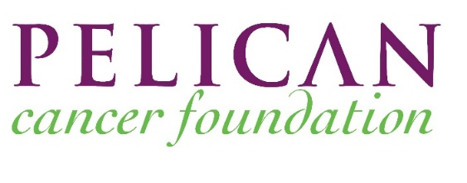



Workshop Booking Form
This workshop will be for the Yorkshire ACPGBI Chapter
Please return to j.staff@pelicancancer.org

ONE FORM PER MDT PLEASE
Date of Workshop | Venue | Yorkshire Chapter Hospital Name | Hospital lead contact name, and email address
Thursday 13th March 2025 | TBC

MDT members to include: Surgeon, Radiologist, Pathologist, Medical Oncologist, Radiation Oncologist, CNS

Title | First name | Surname | Role e.g. Surgeon, Pathologist | Email address | Dietary Requirements
Notes: If you require any additional members of the team to attend, please make a request when you return the form to: j.staff@pelicancancer.org

