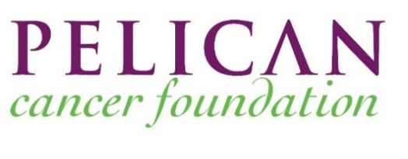
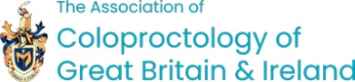
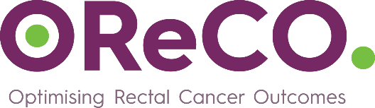
Pelican Cancer Foundation in collaboration with The Association of Coloproctology of Great Britain & Ireland are delighted to invite clinicians from Yorkshire to take part in the one-day Pelican OReCO (Optimising Rectal Cancer Outcomes) Workshop on Thursday 13th March 2025 from 9am until 5pm in York (venue tbc).
Putting patients at the centre of this innovative programme, the interactive workshops will focus on management of rectal cancer with discussions around a number of case studies. Expert panels with local involvement will discuss the patient’s pathway for optimal diagnosis and treatment of rectal cancer in workshops around England, Scotland, Ireland, Northern Ireland and Wales during 2024 to 2026. These workshops form part of an Accredited National Education Programme.

Pelican Cancer Foundation will fund 7 places for colorectal MDT members per hospital from the disciplines of Surgery (x2), Radiology, Pathology, Medical Oncology, Radiation Oncology and Nursing.
The purpose of the Workshop is to:
- Raise awareness on current optimal management of rectal cancer with a focus on surgical techniques.
- Ensure more consistent processes across all colorectal MDTs to support individual patients’ treatment.
- Help all patients have the best treatment, at the best time in the best place.

By attending the Pelican OReCO workshop, you will have the opportunity to discuss complex cases, share experience and uncertainty on the optimal therapy for patients and learn from others to raise standards across all colorectal MDTs in Great Britain and Ireland.
If you would like to attend the YORKSHIRE WORKSHOP, please contact your Colorectal MDT Lead within your hospital.
To find out more about Pelican OReCO please contact:
Jane Staff at Pelican Cancer Foundation: j.staff@pelicancancer.org

www.pelicancancer.org

