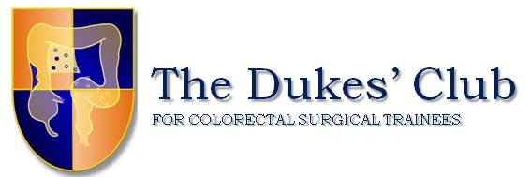
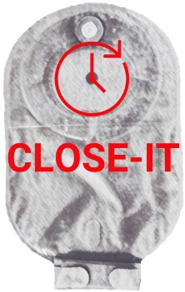
CLOSE-IT
CLOSurE of Ileostomy Timing

Expression of Interest Form

Thank you for your interest in participating in the first Dukes’ Club Research Collaborative Study. Please return the completed form by email to: dukescollaborative@gmail.com by January 25th 2018. We would welcome a team of 2 trainee collaborators and 1 consultant per site, to complete the prospective and retrospective components of the study.

Principal Investigator
Title
First Name
Surname
Qualifications
NHS Hospital Trust
Full address

Tel
Email
Date of last GCP training
Any conflicts of interest for this study?

Site Information
How many patients per year undergo closure of ileostomy in your unit?

Trainee Collaborators
Title
First Name
Surname
Tel
Email
Grade (ST etc.)

Title
First Name
Surname
Tel
Email
Grade (ST etc.)

R & D Contact at Your Site
Job Title
Full Name
Tel
Email
Details of R & D approval process in your trust

Principal Investigator Sign Off
Name:
Signature:
Date:

Thank you for your participation

