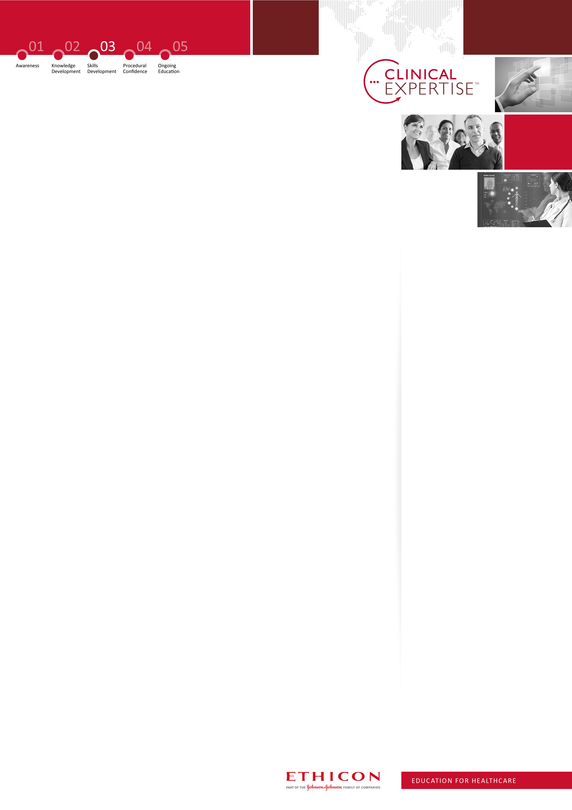
Open Colorectal Surgery Symposium
Date: 10th December 2015
Location: Education Centre, The Christie NHS Foundation Trust, Manchester
OVERVIEW
This Symposium is purely focused around complex and challenging open colorectal surgery. There will be a number of lectures around different aspects of open colorectal surgery, with a focus around case studies of complex cancer cases and the optimal treatment.

Christie Hospital, Manchester
Christie is the largest single site cancer centre in Europe treating more than 44,000 patients per year. Christie specialise in cancer treatment, research and education, and were the first UK centre to be accredited as a comprehensive cancer centre.

AGENDA
8:45  9:00  10.40 | Welcome & introduction & objectives of the symposium  To refer or not to refer:  Chair: Mr Anthony Blower  - Management of Peritoneal metastasis - Prof O’Dwyer (15 min)  - Exenterative techniques and sacrectomy - Prof Sagar (15 min)  - TME – Mr Malcolm Wilson (15 min)  - The perfect Stomas – Prof. Per Nilsson (15 min)  Panel discussion (20 min)  Coffee break (20 min)  Chair: Mr Nigel Scott  - Anastomotic leak and management –Mr Nigel Scott (20 min)  - Intestinal Failure and Prevention – Mr Mattias Soop (20 min)  Human factors – To avoid complications – Selvasekar (20 min)  Panel Discussion (20 min)
12.00-13:00 | Lunch break
13:00  14:00  14:45 | State of the art lecture: Role of Surgery in IBD: Is it changing? Chair Mr. Omer Aziz  Challenging and complex cases  - Interactive MDT case study session (Paul Fulford)  Coffee break  Presentation of selected cases by audience
16:30 | Q&A, feedback, Close

GENERAL INFORMATION
TARGET AUDIENCE: Consultant Surgeons and post CCT colorectal trainees
LEARNING OBJECTIVES: Forum for discussion of challenging and complex open cases.
NUMBER OF DELEGATES: 100
FACULTY
Mr Selvasekar, Consultat
The Christie (Course convener)
Mr Omer Aziz, Consultant Christie Hospital
Mr Paul Fulford, Consultant
The Christie

Prof ST O’Dwyer, Consultant
Christie Hospital
Mr Anthony Blower, Consultant The Christie
Dr Rohit Kochhar, Consultant Radiologist. The Christie
Mr Scott Brown, CNS,
The Christie
Prof Peter Sagar, Consultant
Leeds Hopsital
Mattias Soop, Consultant
Hospital
Mr Omar Fiaz, Consultant Colorectal Surgeon, St Marks Hospital, London
Mr Nigel Scott, Consultant
Lancashire Teaching Hospitals NHS Foundation Trust

European Faculty

Prof. Per Nilsson, Consultant
Karolinska University Hospital

Mr Malcolm Wilson, Consultant
The Christie
CONTACT INFORMATION
KEVIN SCALES
Professional Education Manager- Ethicon Surgical Care
Mobile: +44 (0) 7733 003318
Email: kscales1@its.jnj.com

PROFESSIONAL EDUCATION EVENTS TEAM
Tel: +44 (0) 1530 561509
Email: profed@its.jnj.com
Agenda content & timings may be subject to change
CPD points applied

